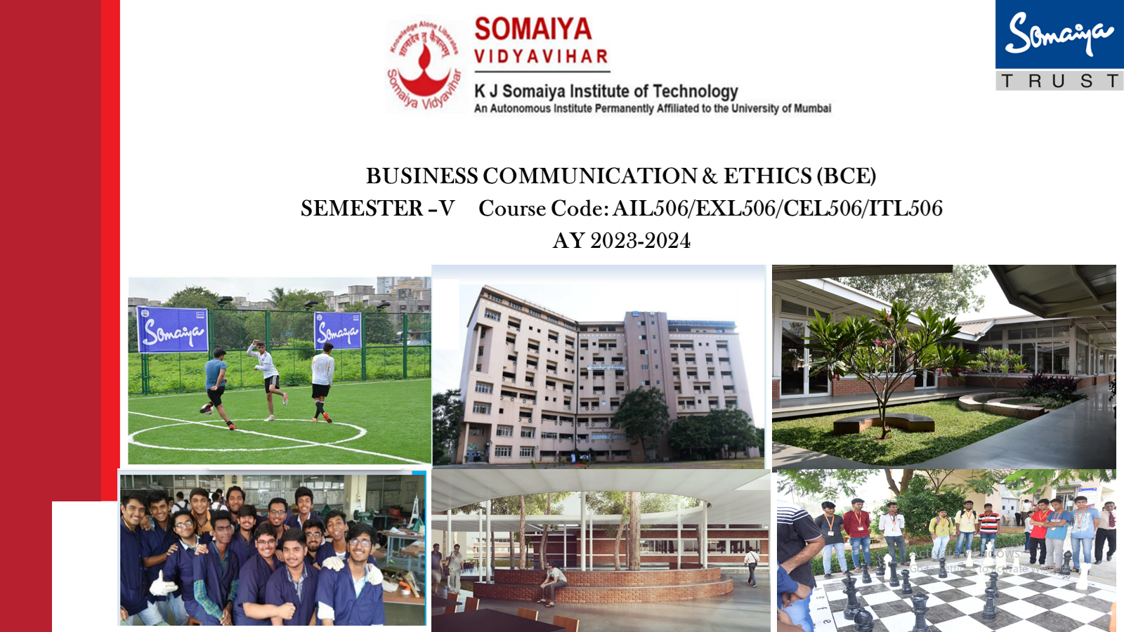**Department of Information Technology**

**Report on**

**Computer Graphics and Vision in Radiology**

**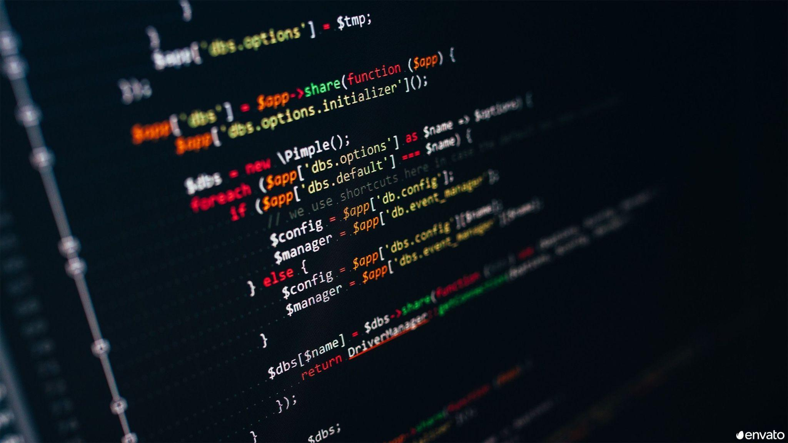*Submitted in partial fulfillment of the syllabus of Business Communication & Ethics***

**Under the Guidance of**

**Dr. Anita Padhye**

**By**

**Batch: T3 Group No.: 3**

**TY IT**

**November 2023**



**Report on**

**Computer Graphics and Vision in Radiology**

**By**

**Batch: T3 Group No.: 3**

**T.Y IT**

| **Sr. No** | **Contributors** | **Roll No.** |
| --- | --- | --- |
| 1 | Ikrama Sunasra | 47 |
| 2 | Bhavya Thakkar | 48 |
| 3 | Riddhi Vaze | 49 |
| 4 | Anoushka Vyas | 50 |
| 5 | Rohit Yadav | 51 |
| 6 | Aniruddha Zore | 52 |
| 7 | Chirayu Agrawal | 53 |

**Under the Guidance of**

**Dr. Anita Padhye**

**November 2023**



**CERTIFICATE**

***This is to certify that the report titled “Computer Graphics and Vision in Radiology” is submitted in partial fulfillment of the syllabus of Business Communication & Ethics by Group 3, Batch T3, Branch Information Technology, during the AY 2023-2024 is found to be satisfactory.***

**Dr. :**

**Internal Examiner:**

**Dr. /Prof. :**

**External Examiner:**

**METHODOLOGY**

The research methodology applied to the project titled “*Computer Graphics and Vision in Radiology''*—the work , strives to focus on the following—to give readers better understanding of their differences and the interplay between them, their current status, their future, their history and most importantly, their benefit to people’s everyday life.

The project has been premised on synthesis of various methodological tools. The *qualitative* approach of the project was aimed to evaluate how computer vision and graphics work, their evolution, their scope of work and most significantly, their limitations. Additionally, the following collection techniques were applied to the project as well:

* Research Papers
* Books
* Journals
* Online resources ( Ted-Talks, Websites, etc.)

The contributing resources were in the form of referring to relevant research papers as well as referencing video clippings. In addition, Ted talks, exclusive books on relevant topics have been vital contributory parameters for collecting the primary data.

The qualitative analysis was the potential approach that was applied in detail to interpret the findings that support the main premise of the project.

**ACKNOWLEDGEMENTS**

First and foremost, a*s* ateam*,* we would like to display our deepest gratitude to our project guide Dr. Anita Padhye who gave us a golden opportunity to work on the project titled ***“Computer Graphics and Vision in Radiology”***. The amount of ideas, motivation and guidance provided by our guide has been monumental for completing our project.The quality of mentoring provided by our guide has resulted in bringing out the best researcher in each one of us.

It is also our humble opportunity to thank our College — **K J Somaiya Institute of Technology (KJSIT)** & its authorities—Dr. Suresh Ukarande, Principal, for providing invaluable resources—the library books, the recent infrastructural resources. A sincere thank you gesture to our Head of the Department Dr. Radhika Kotecha of the Information Technology branch for extending the departmental support with relevant guidance on all occasions.

Besides, we would like to thank all the faculty and staff who helped us by giving us advice and providing the equipment which we needed for completion of this project. On the same note, we wish to thank our fellow classmates as the idea of preparing an insightful presentation on “Computer Graphics and Vision in Radiology” was inspired by a few creative team members. We would also like to thank our friends for providing us with information regarding different surveying websites. We would like to express our heartfelt gratitude to our parents who constantly supported us throughout our journey.

**PREFACE**

The concept of computer vision and graphics has become one of the significant components of our everyday life. Their synergy has changed the radiology field as a whole with much better prediction and result and no doubt with future exploration will result in much higher evolution of the field and much unimaginable results.

Computer Vision is essentially in the process of evolving as we speak. It still remains largely unexplored because of the mammoth amount of data it requires to perform. It is a relatively new domain, which deserves study.

While computer graphics is a much explored arena, everyday it continuously evolves too but much smaller in comparison. It is a relationally easier process but it involves a lot of time and dedication.

Computer vision and graphics are often researched differently but it is remarkable what they can achieve together. The recent surge into their combined usage has already delivered some unimaginable results. However, their limitations still continue to be a barrier, specially the privacy issue they generate. But careful utilization of these will no doubt yield outstanding results which will be helpful in enhancing everyday life. This project ***aims*** to help readers understand the evolution of radiology due to the synergy between computer graphics and vision.

**ABSTRACT**

Computer visionis a ***artificial intelligence subset***, which is used to train models for human interaction to enhance everyday life of the people, while computer graphics is all the visuals on a display. The ***purpose*** of this project is to have a better understanding of the concept in an effective way so that an individual would be able to identify different opportunities to better their everyday life using computer vision and graphics. When the person is able to understand this concept, they will be able to use them for carrying out their work more efficiently and easily while achieving their desired goals.The ***methodology*** applied to the project is qualitative analysis of various available sources. The ***outcome*** of the study points towards that the larger domain of computer vision still remains unexplored but still we are able to perform a variety of task using the current domain of it, while computer graphics remains a domain we explored much more in comparison to computer vision mainly due to difference in their complexity as well as their price. Furthermore, the limitations of the current gen need to be remembered as to ensure their application proves to be efficient, and useful to the people’s everyday life as well as to the society as a whole. ***The main areas that are highlighted*** in this project are computer graphics, computer vision, their evolution in 20th century, their modern day application and most significantly, their future role in context of the present gen limitation.

**TABLE OF CONTENTS**

| **Sr. no** | **Topics** | **Page No.** |
| --- | --- | --- |
| i. | ***Certificate*** | iii |
| ii. | ***Methodology*** | iv |
| iii. | ***Acknowledgements*** | v |
| iv. | ***Preface*** | vi |
| v. | ***Abstract*** | vii |
| vi. | ***Table Of Contents*** | viii |
| vii. | ***List Of Illustrations*** | ix |
| 1. | ***Introduction***  1.1 Background  1.2 Definition  1.3 Scope  1.4 Limitations  1.4 Chapter Scheme | 1  2  3  4  5  5 |
| 2. | ***Evolution of Computer Graphics and Vision***  2.1 History of early age Computing Technology  2.2 Whirlwind and SAGE  2.3 Emergence of CG Organizations and Conferences | 7  7  8  10 |
| 3. | ***Applications of Computer Graphics and Vision***  3.1 Design  3.2 User Interfaces  3.3 Machine Drawing  3.4 Visualization  3.5 Education  3.6 Entertainment  3.7 Presentation Graphics  3.8 Computer Art  3.9 Training  3.10 Image Processing | 15  15  16  17  17  18  18  18  18  19  20 |
| 4. | ***Applications in Radiology***  4.1 Diagnostic radiology  4.2 Interventional radiology (IR)  4.3 Radiation therapy  4.4 Artificial Intelligence (AI)  4.5 Emerging Trends and Challenges | 21  21  24  25  27  28 |
| 5. | ***Conclusion and Recommendations*** | 31 |
| viii. | ***List of References*** | x |

**LIST OF ILLUSTRATIONS**

| **Sr.No.** | **Illustrations** | **Page No.** |
| --- | --- | --- |
| 1 | Fig. 1.1 Tesla Self-Driving Mode | 1 |
| 2 | Fig. 1.2 Japanese Robot Cafe | 1 |
| 3 | Fig. 1.3 Game Rendering Editor | 2 |
| 4 | Fig. 1.4 Computer Vision | 3 |
| 5 | Fig. 2.1 The Whirlwind computer at MIT (circa 1951) | 9 |
| 6 | Fig. 2.2 Various Conferences and Organizations | 11 |
| 7 | Fig. 2.3 First UAIDE Conference | 13 |
| 8 | Fig 3.1 Application of Computer Graphics and Vision | 15 |
| 9 | Fig. 3.2 Rendering Software | 17 |
| 10 | Fig. 3.3 Training Model Flow | 17 |
| 11 | Fig. 3.4 Computer Art | 19 |
| 12 | Fig. 3.5 Security Camera Console | 19 |
| 13 | Fig. 4.1 X-ray | 22 |
| 14 | Fig. 4.2 Magnetic Resonance Imaging (MRI) | 23 |
| 15 | Fig. 4.3 Uterine Fibroid Embolization | 24 |
| 16 | Fig. 4.4 Radiation Therapy | 25 |
| 17 | Fig. 4.5 Stereotactic Body Radiation Therapy | 26 |

**Chapter 1**

**Introduction**

Ever wonder what exactly “***Computer Graphics and Vision”*** means. We see it everyday and just do not realize it. Self Driving Cars, Robots Serving Restaurant, 3D Rendered Models all use computer vision and graphics.

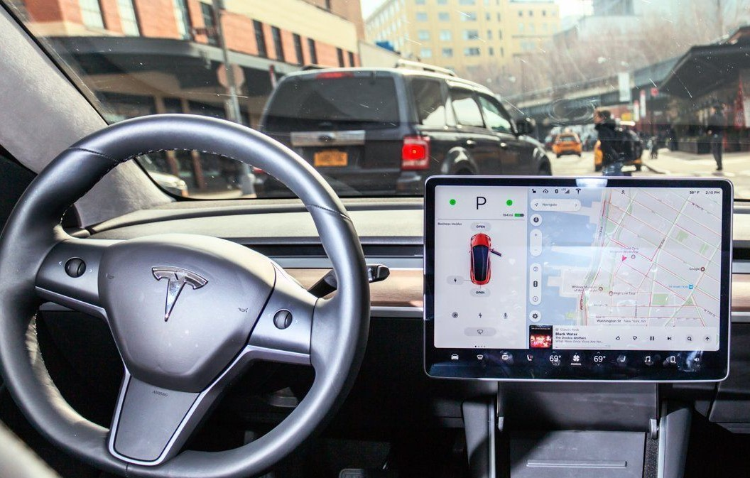

**Fig. 1.1 Tesla Self-Driving Mode**

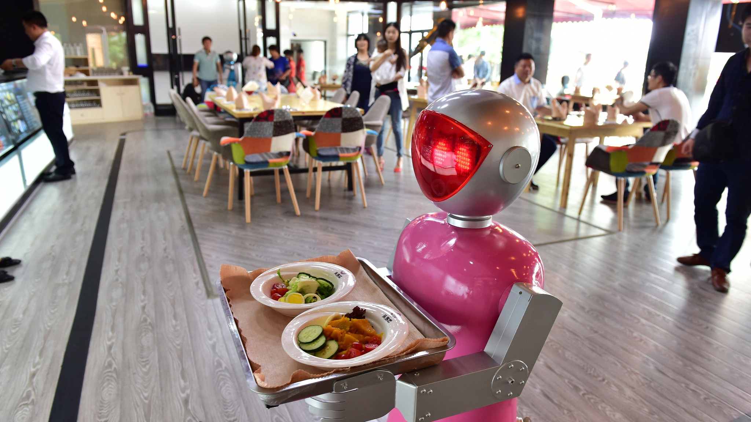

**Fig. 1.2 Japanese Robot Cafe**

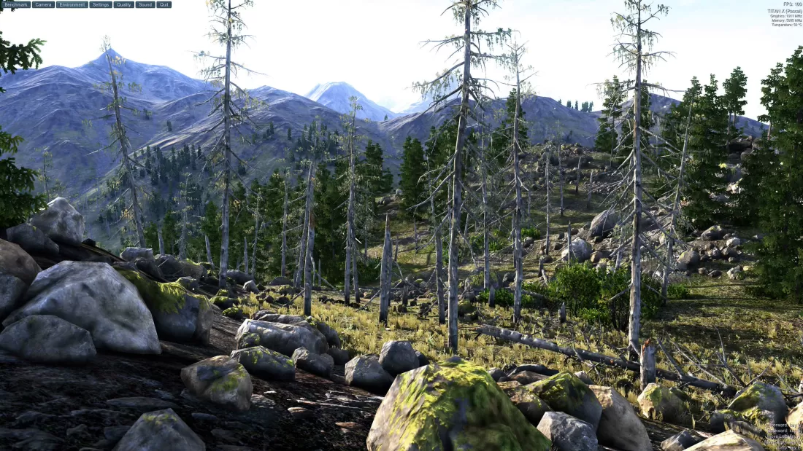

**Fig. 1.3 Game Rendering Editor**

**1.1 Background**

Human Beings observe, perceive, contextualize, and make sense of our surroundings through a brace of natural cameras: *eyes*. They may not have the ability of recording, storing, and assaying visual data, but they help us see objects, orient ourselves in different settings, and authentically enjoy the beauty around us. Imagine having millions of eyes that we can place anywhere we want, literally anywhere. Imagine using them to get any information we need in a snap. How would these eyes ease our lives? In innumerous possible ways. Now, what can be more fascinating than the fact that those eyes live and the script above is not a fantasy? With this in mind, let’s take a dive deep into the has-been miracle computer vision.

These days, we use computers and smartphones to do a lot of tasks, watch films and play games, but we did not ask ourselves how the graphics are created in the computer, which will be answered thoroughly through this report. The term computer graphics was known in the early 1960s by William Alan Fetter, a graphic designer for a company, Boeing America,while the term computer vision was coined in 1960 by Robert Fischell.

This report was created for those who want to know the history of computer graphics and vision, how they work, and their profound impact on various industries and their use in everyday life and a detailed application in the medical field of radiology with their limitations and future opportunities.

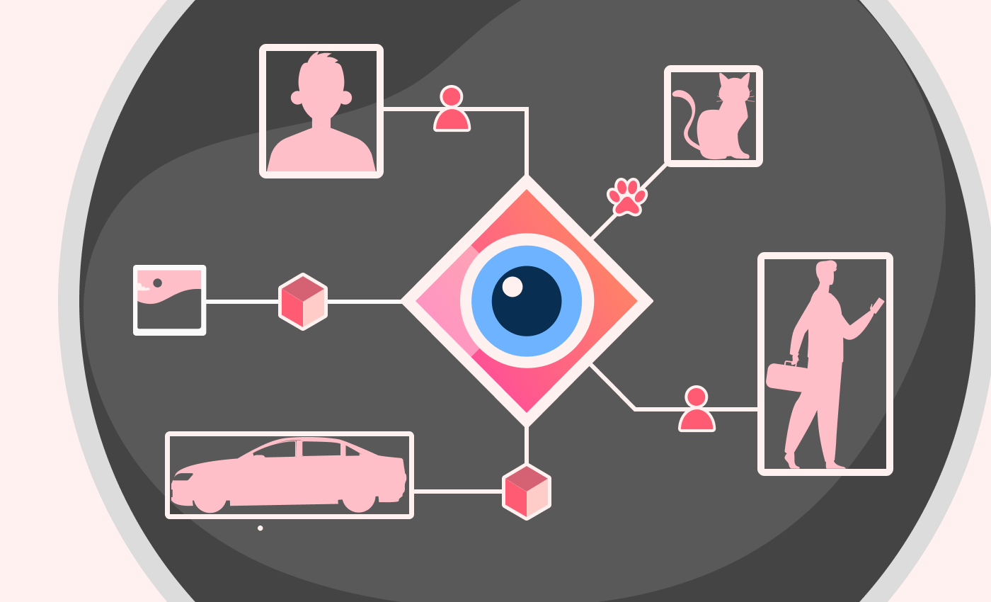

**Fig. 1.4 Computer Vision**

**1.2 Definition**

*A]* Computer Graphics

Computer graphics can be defined as the representation of visual data on computers, encompassing everything that isn’t text or sound. It involves the transformation of an image into data, or the creation of an image from data, which is then processed by a computer to produce graphics.[1] Computer graphics are widely used in various sectors today, including newspapers, weather forecasting, and medical fields for imaging, surgical procedures, and graphs to simplify complex concepts. Numerous tools have been developed to transform data or images into computer graphics. There are several types of computer graphics: two-dimensional graphics, three-dimensional graphics, and animations. As technology advances, three-dimensional graphics have become more prevalent, although two-dimensional graphics are still utilized in certain areas.

*B]* Computer Vision

Computer vision is a branch of artificial intelligence (AI) that imparts the ability to computers and systems to extract valuable information from digital images, videos, and other visual inputs. It equips computers with the capability to see, observe, and comprehend their surroundings. While it mirrors human vision, it relies on cameras, data, and algorithms instead of retinas, optic nerves, and a visual cortex. It finds applications in numerous industries and is projected to continue its growth.[2] Notably, computer vision necessitates a substantial amount of data and employs machine learning techniques to distinguish differences and ultimately recognize images.

Computer vision and graphics are two intertwined domains that have drastically changed our interaction with digital media.The amalgamation of computer vision and graphics has paved the way for new opportunities in numerous fields, including virtual reality (VR), augmented reality (AR), gaming, healthcare, and autonomous vehicles. For example, in AR applications, computer vision algorithms are employed to track objects in the real world, while graphics techniques are utilized to project virtual objects into the real-world scene.Both fields are evolving rapidly with advancements in machine learning and AI, leading to more sophisticated applications that continue to transform our digital experiences.

**1.3 Scope of the Study**

Understanding computer vision and graphics entails a thorough understanding of computer vision, computer graphics, their definition, and their significance in empowering machines to interpret visual data. This understanding is deepened by discussing the impressive development and advancements of computer vision and graphics over time, transitioning from basic image recognition to its present intricate and precise state to 3-D modeling it. The report further explains the interplay between computer vision and graphics for extracting valuable information from images. Furthermore, it discusses their evolution stages. Finally, it explores radiology application in computer vision and graphics.The diverse applications of computer vision and graphics in various sectors such as autonomous vehicles, healthcare, medicine, etc., are also discussed. The report concludes by discussing how computer vision and graphics is revolutionizing industries and creating new opportunities, with an emphasis on its potential future influence.

**1.4 Limitation of the Study**

Both computer graphics and vision systems are becoming increasingly complex due to users' demands for advanced tools, posing challenges in understanding and implementing these systems. Modern computer graphics and vision software and tools can be costly, potentially limiting individual users or small organizations. Despite significant strides, there are still technical limitations in computer graphics and vision. For instance, computer graphics cannot understand real-world situations or operate based on real-life principles, and computer vision can struggle with understanding context, recognizing objects in different lighting conditions or from different angles, and distinguishing between similar objects. Additionally, computer graphics and vision applications often require significant computational resources, which can be a limitation for some organizations. Privacy concerns can also arise with the use of computer vision, particularly in areas like facial recognition. Lastly, implementing computer graphics and vision requires specialists in the field of Machine Learning and Artificial Intelligence who understand how these devices work and how to maximize the use of computer vision.

**1.5 Chapter Scheme**

A scheme refers to the structure or plan that is followed to write the report. The need for a scheme in a report is crucial for several reasons like to organize thoughts and ideas in a logical manner, making the report easier to understand and follow while also ensuring a smooth flow of information from one point to another, maintaining the continuity and comprehensiveness of the report while also helping in time management while further advancing the clarity of purpose of the report.

The scheme in the report is as follows:

* **Chapter 1** provides the basic brief tocomputer graphics and vision by providing their definition, background, scope and limitations.
* **Chapter 2** consists of various evolution stages computer graphics and vision went through spanning all over the 20th and 21st centuries.
* **Chapter 3** offers a brief report on all the present applications of computer graphics and vision in everyday life.
* **Chapter 4** provides a detailed description of application computer graphics and vision in the medical field of radiology.
* **Chapter 5** provides a conclusive view on the whole report and closing remarks.

**Chapter 2**

**Evolution of Computer Graphics and Vision**

**2.1 History of early age Computing Technology**

The study of the history of CGI( computer generated imagery) is an important part of our overall educational experience, not inescapably to make on the literal precedent, but to gain an understanding of the elaboration of our discipline and to gain a respect for the crucial developments that have brought us to where we are. The discipline is so recent in its early developments and so fleetingly changing that we're in fact living it, and it evolves as we speak.[3] Yet we've been so busy advancing the discipline that we've frequently neglected to directly record this history. So we will decide to agree upon certain events in order to begin to develop a definitive record of what has occurred in this evolutionary process.

We must learn from history, as we develop a proposition and methodology which is tuned to the capabilities and rates essential in software, tackle, vitality ways,etc. that are part of our broad, contemporary, and creative computer graphics terrain. It's in this environment that this ebook has been developed.

Herbert Freeman, in a preface to his 1980 IEEE compendium of computer plates papers, presents a brief overview of the first two decades of the development of the CGI discipline. Like numerous other disciplines, computer graphics and animation has a rich (albeit fairly short) history that involves the following four ages, which are very much linked and related:

1. **Pioneers**
2. **Innovators**
3. **Adapters**
4. **Followers**

Early pioneers include artists (such as John Whitney) and researchers (such as Ivan Sutherland)[]. These visionaries saw the possibilities of the computer as a resource for making and interacting with computer pictures, and pushed the limits of an evolving technology to take it where computer scientists noway imagined it could go. Their work motivated the work of the others as they tried to realize the eventuality of this new vision. In this book, we will survey work from numerous different artists.

Numerous of the so- called originators were housed in universities and exploration labs, and were working toward solving fundamental problems of making “pictures” of data using the computer. The early appendages included pioneering CGI production facilities, artists, experimenters, and exploration labs, and industries with an interest in converting much of this early work into a feasible( and marketable) tool for realizing their distant pretensions.[4] Notable companies include Robert Abel and Associates, Digital Effects, and many more. Artists include more from Whitney Sr., David Em, and numerous others.

The late seventies and early eighties saw the alternate surge of appendages, which were primarily special effects production companies, equipment and software developers, motion picture companies, numerous others.

As the technology advanced and the acceptance of this new approach to image making increased, the industry evolved likewise, and many of the current followers came into being. These include effects production companies such as Pixar, Disney, Metrolight, and many others. We will look at the impact on related areas, such as , design, multimedia, virtual reality, scientific visualization, etc., with detailed focus on its usage in radiology.

**2.2 Whirlwind and SAGE**

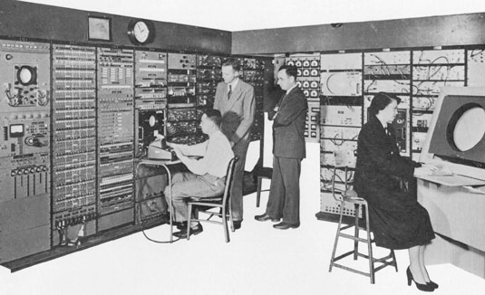

**Fig. 2.1 The Whirlwind computer at MIT (circa 1951).**

The continuous evolution of the digital computer furthered with the Whirlwind computer. Development of the Whirlwind began in 1945 under the leadership of Jay Forrester at MIT, as part of the Navy’s Airplane Stability and Control Analyzer (ASCA) design.[5] The system was proposed in order to give a “programmable” flight simulation environment and was first demonstrated in 1951. This was not the first digital computer, but it was the first computer able to display real time text and graphics, using a large screen.

Whirlwind entered positional data related to an aircraft from a radar station in Massachusetts. The Whirlwind programmers had created a series of data points, displayed on the screen, that represented the east seacoast of Massachusetts, and when data was entered from radar, a symbol representing the aircraft was superimposed over the geographic drawing on the screen of a CRT. Robert Everett (later CEO of Mitre Corporation) designed an input device, which was called a light gun or light pen, to give the operators a way of requesting identification information about the aircraft. When the light gun was pointed at the symbol for the plane on the screen, an event was sent to Whirlwind, which then sent text about the plane’s identification, speed and direction to also be displayed on the screen.

Forrester chose not to employ the new mercury delay line memory or electrostatic storage tubes due to their performance and cost. Instead, he explored a magnetic ceramic known as Deltamax, which could retain a change of state indefinitely when subjected to magnetic pulses. This was known as core memory, and each component was a doughnut-shaped metal with two electrical wires threaded through it. Individually, neither wire had enough power to alter the magnetism’s state, but combined, they did. As a result, it served as a storage and access medium that could be addressed randomly.

This image shows a core memory component from the Whirlwind computer. The bank, approximately 14 inches square, contains 32×32 bits. The Whirlwind project was a significant part of the Office of Naval Research budget, making it a target for congressional budget cuts. In 1951, there were threats to reduce its allocation from $1.15M to $0.25M. However, intense lobbying by MIT led to the U.S. Air Force adopting the Whirlwind computer for its new SAGE (Semi-Automatic Ground Environment) air defense system. This system, with advanced display capabilities, became operational in 1958.

In this photo from around 1951, Stephen Dodd, Jay Forrester, Robert Everett, and Ramona Ferenz are seen at the Whirlwind I test control in the Barta Building at MIT.

The Deltamax core was replaced by faster ferrite core memory in 1953. Although RCA applied for the contract to manufacture SAGE, it was ultimately awarded to IBM. IBM installed two Whirlwind computers in each of the 23 Air Force SAGE centers.

Following the launch of Sputnik, the Air Force shifted its focus from long-range bombers to intercontinental ballistic missiles. As a result, the Whirlwind-based SAGE computers were phased out. The last of these computers was shut down in 1983, marking a record for operational longevity among early digital computers.

**2.3 Emergence of CG Organizations and Conferences**



**Fig. 2.2 Various Conferences and Organizations**

In 1947, the Association for Computing Machinery (ACM) was established by computing professionals to offer professional and educational opportunities to its members. Today, it boasts around 75,000 members from all areas of the computing field.

The American Federation of Information Processing Societies (AFIPS) was founded on May 10, 1961, with the aim of advancing and disseminating knowledge in information science and representing member societies internationally.[6] AFIPS originated from the National Joint Computer Committee, established in 1951 to sponsor the Joint Computer Conferences. The founding societies of AFIPS included the ACM, the American Institute of Electrical Engineers, and the Institute of Radio Engineers (which later merged to form the IEEE, or Institute of Electrical and Electronic Engineers). AFIPS is known for sponsoring the Joint Computer Conference, which was renamed the National Computer Conference in October 1973. These semi-annual conferences, which featured technical sessions and exhibits related to information processing, were discontinued after 1987 due to the organization’s financial situation.

A unique feature of the ACM is its Special Interest Groups (SIGs), originally known as Special Interest Committees (SICs). Each of these 35 SIGs represents a specific area of computing. Like the overarching ACM organization, each SIG is governed by a board composed of volunteer members.

In 1967, Sam Matsa, a member of the ACM Board who began his career as part of the IBM/GM collaboration that led to DAC-1 and the IBM 2250 display, and Andy Van Dam of Brown University organized a professional development seminar in graphics. This was part of a larger series of seminars that Matsa persuaded ACM to sponsor. These seminars were held across the country, attracting 40 to 50 attendees each time.In these graphics seminars, Van Dam covered the hardware aspects, while Matsa focused on the software.

The interest in graphics, as demonstrated by the attendance at these seminars, led Matsa and Van Dam to persuade ACM to establish a Special Interest Committee in Graphics. This led to the creation of SIGGRAPH, with Matsa serving as the founding Chairman and Van Dam as Secretary, responsible for organizing the SIC newsletters.

In 1969, members sought recognition for their field in the same way other computing disciplines were recognized - with elected rather than appointed officers. A lobbying effort gathered enough signatures to convince ACM to upgrade the SIC to a Special Interest Group status, leading to the establishment of ACM-SIGGRAPH. Ed Devine was its first elected chair. Jon Meads named it SIGGRAPH: the Special Interest Group on Computer Graphics and Interactive Techniques in the bylaws, acknowledging both the graphics and human interaction aspects of the field.

The organization was involved in wider ACM conferences and published a quarterly newsletter. Interests ranged from simulation and modeling, text editing and composition, computer-generated art, cartography and mapping, computer-aided design, to computer graphics software and hardware.

In 1973, the first annual SIGGRAPH conference was organized by Meads and Bob Schiffman, which has since become a key feature of the organization. The inaugural conference took place in Boulder, Colorado in the summer of 1974 as the 1st Annual Conference on Computer Graphics and Interactive Techniques, attracting around 600 attendees. No formal proceedings were published; instead, the papers were included in a lesser-known journal from Pergammon Press. The subsequent two conferences held in Bowling Green, Ohio and Philadelphia had moderate success. However, the 1977 conference at a Hyatt in San Jose was a major success, paving the way for decades of successful and significant SIGGRAPH conferences. The Proceedings of the Conference continue to be a respected scholarly journal for publishing technical contributions.

Tom DeFanti, an Ohio State graduate and former SIGGRAPH Chair, organized film and video presentations at the early conferences. In 1979, he began publishing them as the SIGGRAPH Video Review. These sessions are now known as the Electronic Theatre, part of the Computer Animation Festival, a juried conference event. In 1995, Frank Foster arranged for this visual showcase to be held in a formal theater setting away from the conference venue at the renowned Shrine Auditorium in LA.



**Fig. 2.3 First UAIDE Conference**

Over time, Panels and Courses were introduced, an Art Show became a regular feature, and spaces for emerging technologies were provided. Several related conferences occasionally co-located with SIGGRAPH, and an Education track was added to the conference offerings.

Working groups for Pictures and Multimedia, Computer Graphics and AI, Computer Graphics Hardware, Scientific Visualization, and Relationships Between Image Synthesis and Image Analysis were formed during this period.

In 1991, Jürgen Schönhut was elected chairman of the EG Association. The editorship of Computer Graphics Forum was transferred to NCC Blackwell Publishers with H.P.Seidel as its new chief editor. In 1992, David B. Arnold assumed the role of Chair. A new agreement was made in 1993 with Springer Verlag to publish the Eurographics Workshops in the new “Focus on Computer Graphics” series. EG established its web presence in 1995 under the leadership of Ivan Herman.

In May 1996, at a workshop on the future of Eurographics, EG’s main focus was defined as “an association of professionals to help professionals in their careers in computer graphics and interactive digital media”. Under the presidency of W.T.Hewitt, a liaison agreement with the Chinese Computer Graphics association was signed that year. The following year saw the inauguration of the Eurographics publications catalog on the website www.eg.org, replacing the printed catalog.

In 1999, under Dieter Fellner’s leadership, the Online Board was established and the cooperation agreement between Eurographics and SIGGRAPH was renewed. In 2000, as a result of this cooperation, EG operated a stand outside the exhibition area next to SIGGRAPH for the first time, demonstrating EG’s standing in the graphics world. That same year saw a cooperation agreement signed with IEEE TCVG and the start of digitization of back issues of Computer Graphics Forum.

**Chapter 3**

**Applications of Computer Graphics and Vision**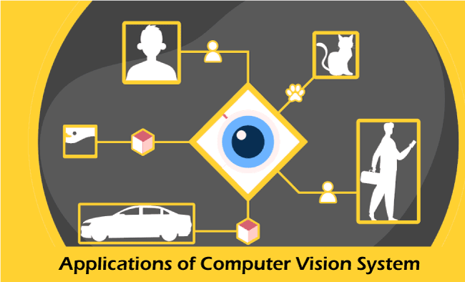

**Fig 3.1 Application of Computer Graphics and Vision**

Some of applications of Computer graphics and Vision are:

1. **Design**
2. **User Interfaces**
3. **Machine Drawing**
4. **Data Visualization**
5. **Education**
6. **Entertainment**
7. **Presentation Graphics**
8. **Computer Art**
9. **Image Processing**
10. **Training**

**3.1 Design**

Development is often linked to disciplines such as engineering and architecture. Despite the fact that most developers encounter similar challenges and employ comparable methodologies in their work, the absence of a one-size-fits-all solution is a characteristic feature of many design problems.[7] Thus, the inventor must dissect and also change a possible design, presumably several times, to try to find a better result.

In this iterative process, computer graphics has become an essential element. For illustration, consider how computer graphics could hit the electronic circuit layout. The programmer sits with a graphics input device, such as the mouse, at a workstation where he can mark the positions on a display. The original display screen may consist of different items to be used in the circuit and an empty area where the circuit is installed.

The developer will also pick and transfer the desired items and attach them to the model with the input device. In order to make this first model, the system uses sophisticated computer graphics. Circuit items are drawn and the screen may be shifted. For options and locations, a graphical input tool is used. A variety of aides may be used to help the developer correctly locate the items and to perform tasks like routing the cables automatically.

**3.2 User Interfaces**

By using computer graphics, the interface between humans and machines has been drastically altered. Take into account the digital office. The numbers in this research have been generated by a single interface. Rather than a desk with a typewriter, a customer sits at a workstation. The client has a pointing system like a joystick to interact with the workstation.[8] There are numerous icons describing the different operations that can be performed by the customer.

The user should dispose of unwanted emails by an icon of a paper box, whereas a cabinet icon can be used to save letters or other documents. Our circuit design framework will include a similar graphical interface. We see these interfaces as obvious uses of computer graphics in the context of this book. The images, however, are the secondary elements of the project, from the viewpoint of the secretary with the use of the Office Automation or the circuit programmer. While graphics programs are never written, most computer users use computer graphics.

**3.3 Machine Drawing**

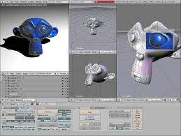

**Fig. 3.2 Rendering Software**

Computer graphics are frequently utilized in the design, alteration, and creation of various machine components and entire machines. This is primarily due to the precision and clarity that these drawings provide, ensuring the safe production of the machine based on these drawings.

**3.4 Visualization**

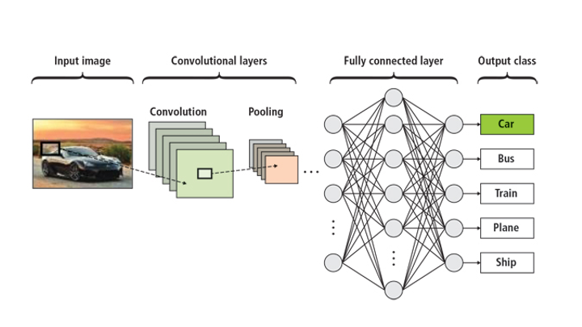

**Fig. 3.3 Training Model Flow**

The demand for visualization has significantly escalated in today’s world, and it’s anticipated that many advanced technologies will require visualization. Data visualization aids in extracting insights from information, enabling us to analyze and understand the compatibility of the systems that surround us.

**3.5 Education**

Computer-generated models are incredibly beneficial for teaching, understanding, and learning a wide range of concepts and principles. Computer graphics can be used to create numerous educational models, which can potentially increase student interest in the subject matter.

**3.6 Entertainment**

A majority of computer graphics applications are utilized in the film and gaming industries. In the realm of film, TV shows, music videos, and animated cartoons, computer graphics play a crucial role in content creation. In the gaming industry, where focus and interactivity are key, computer graphics effectively enhance these aspects.

**3.7 Presentation Graphics**

Computer graphics are used to compile reports or summarize information in various fields such as accounting, politics, mathematics, science, and management. They are also used in the creation of research reports and the development of visual data representations like bar graphs, time charts, and pie diagrams.

**3.8 Computer Art**

**Fig. 3.4 Computer Art**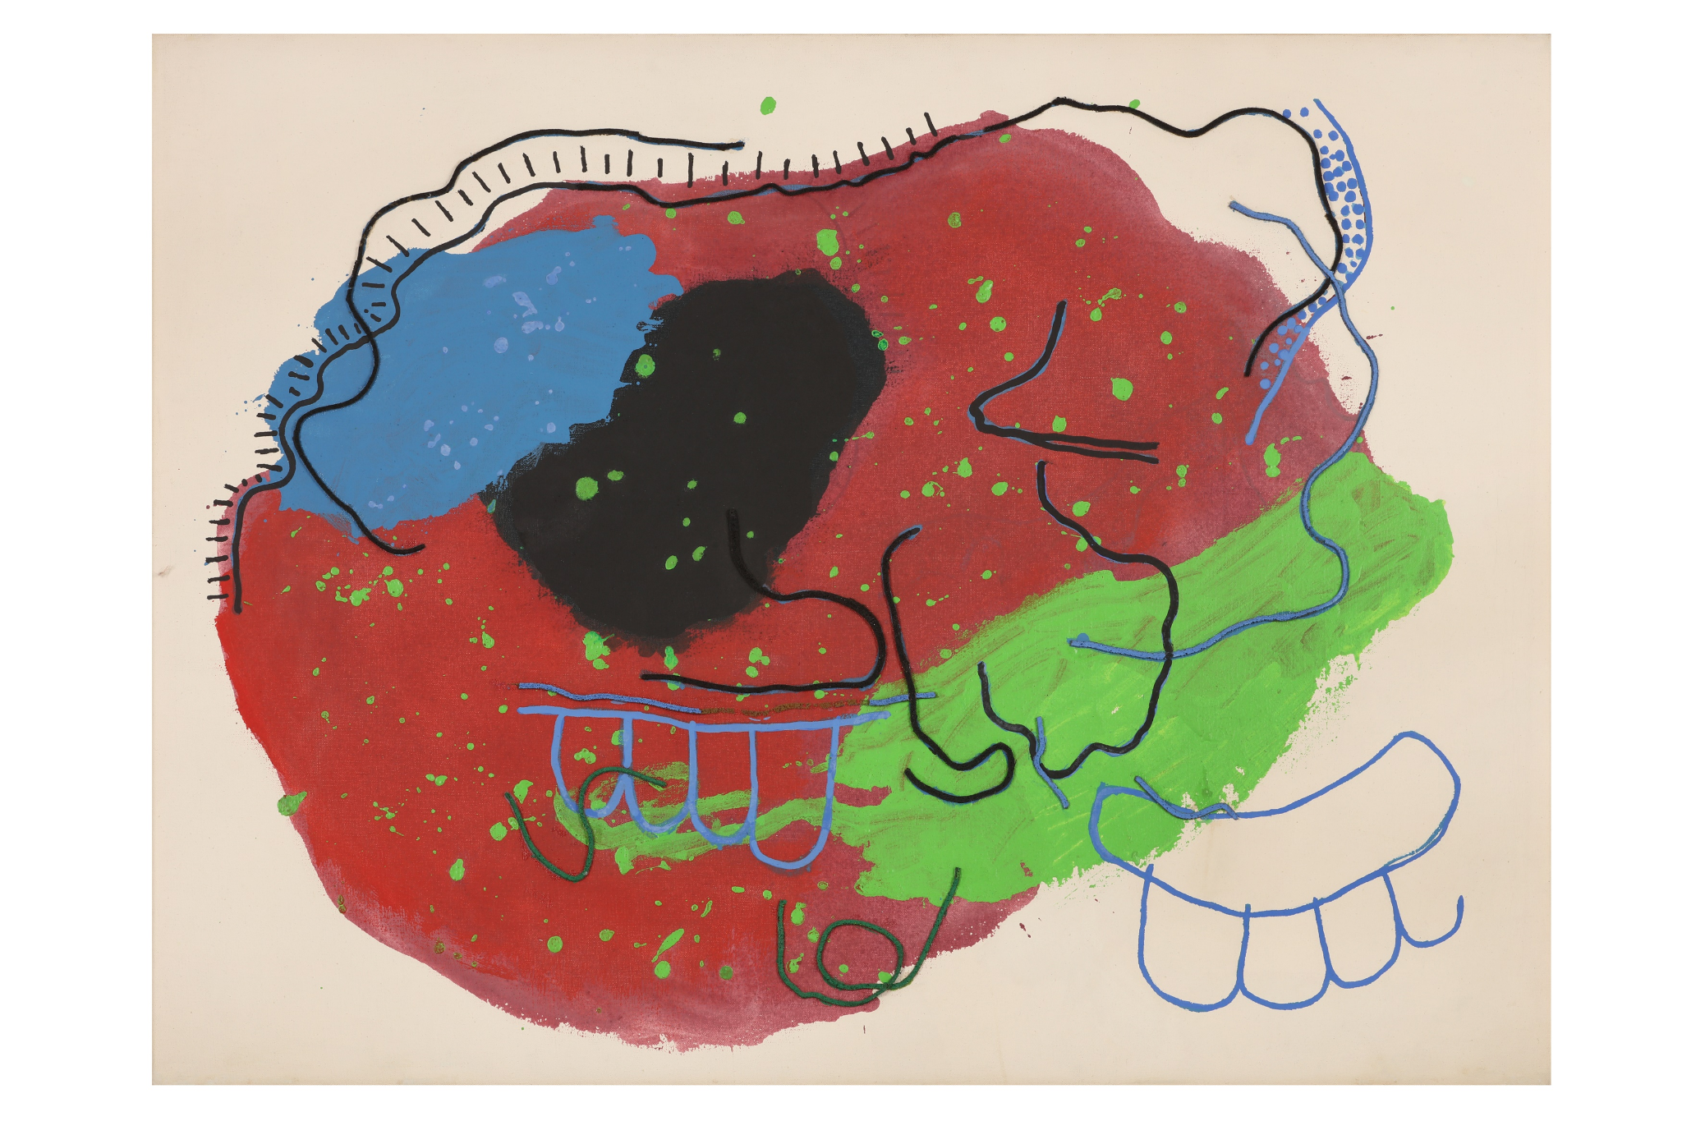

We can produce fine and marketable art through computer graphics which include packages of animation and painting. These packages give the ability to model the shapes of objects and to define the movement of an item.

**3.9 Training**

Specialized training styles like simulators may be used to train candidates so that they can have better understanding over a short period of time. It is simple and veritably useful to make training modules with computer graphics.

**Fig. 3.5 Security Camera Console**

**3.10 Image Processing**

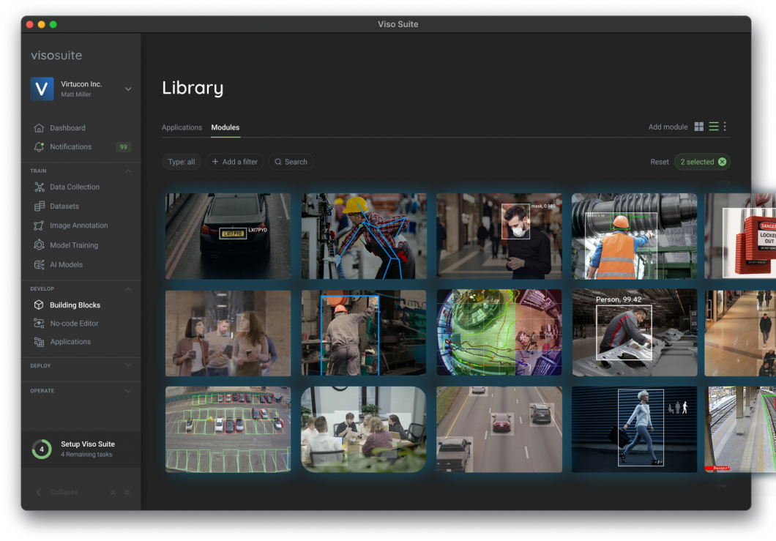

Specific types of photos need to be edited to be used at various locations. One of the numerous ways of computer graphics is to transform existing images into optimized ones for better understanding.[9]

So here we have seen numerous applications of computer graphics. These are some computer graphics applications as their popularity has increased extensively and will continue to increase with technological progress. There is a lot of exploration being done in the computer vision field, but it’s not just research. Real-world applications demonstrate how important computer vision is useful in business, entertainment, and everyday life. A key driver for the growth of these applications is the giant well of visual information flowing from smartphones, security systems, and other visually instrumented devices. This data plays a major role in operations across various industries. The information creates a test set to train computer vision applications and a launchpad for them to learn a part of a range of human activities.

**Chapter 4**

**Applications in Radiology**

The field of radiology holds a paramount position in modern medicine, serving as an invaluable tool for diagnosing, treating, and monitoring a wide array of medical conditions. Radiology, as a medical imaging technique, has evolved significantly since the discovery of X-rays by Wilhelm Conrad Roentgen in 1895. Today, it encompasses a diverse range of applications that provide a non-invasive means of visualizing internal structures, enabling healthcare professionals to make accurate diagnoses and informed treatment decisions.

The significance of radiology in healthcare cannot be overstated. It has fundamentally transformed the way medical professionals approach patient care.[10] Radiology offers a non-invasive, highly informative alternative, reducing patient discomfort, minimizing risks, and expediting the diagnostic process.

Some of applications of radiology include:

1. Diagnostic radiology
2. Interventional radiology (IR)
3. Radiation therapy
4. Artificial Intelligence (AI)

**4.1 Diagnostic radiology**

Diagnostic radiology is the cornerstone of medical imaging, encompassing a rich array of techniques that empower healthcare professionals to visualize the internal structures of the human body with remarkable clarity and precision. These techniques include X-rays, Computed Tomography (CT), Magnetic Resonance Imaging (MRI), ultrasound, and nuclear medicine.

X-rays, among the oldest and most widely employed diagnostic radiology techniques, operate on the principle of radiation penetration. Controlled X-ray beams pass through the body, and the resulting images reveal an intricate tapestry of bones, highlighting fractures, dislocations, dental issues, and various lung conditions. X-rays are a stalwart diagnostic tool, forming the backbone of clinical evaluations and emergency assessments.

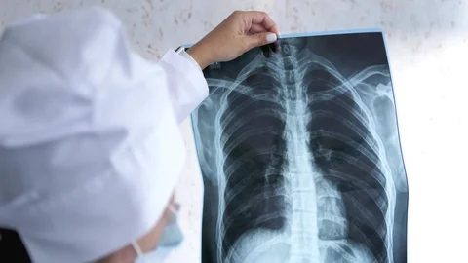

**Fig. 4.1 X-ray**

Computed Tomography (CT) elevates imaging to the three-dimensional realm. CT scans generate cross-sectional images of the body by rotating an X-ray source and detector around the patient.[11] This revolutionary approach provides unparalleled insights into organs and structures, making CT indispensable in imaging the brain, abdomen, and chest. Its applications span from the detection of tumors to the evaluation of trauma.

Magnetic Resonance Imaging (MRI) is the paragon of soft tissue imaging. Employing powerful magnetic fields and radio waves, MRI creates detailed images that distinguish various types of soft tissues within the body. The versatility of MRI is evident in its widespread usage for imaging the brain, joints, and abdominal organs. Neurologists, orthopedic surgeons, and radiologists alike rely on MRI for precise diagnoses.

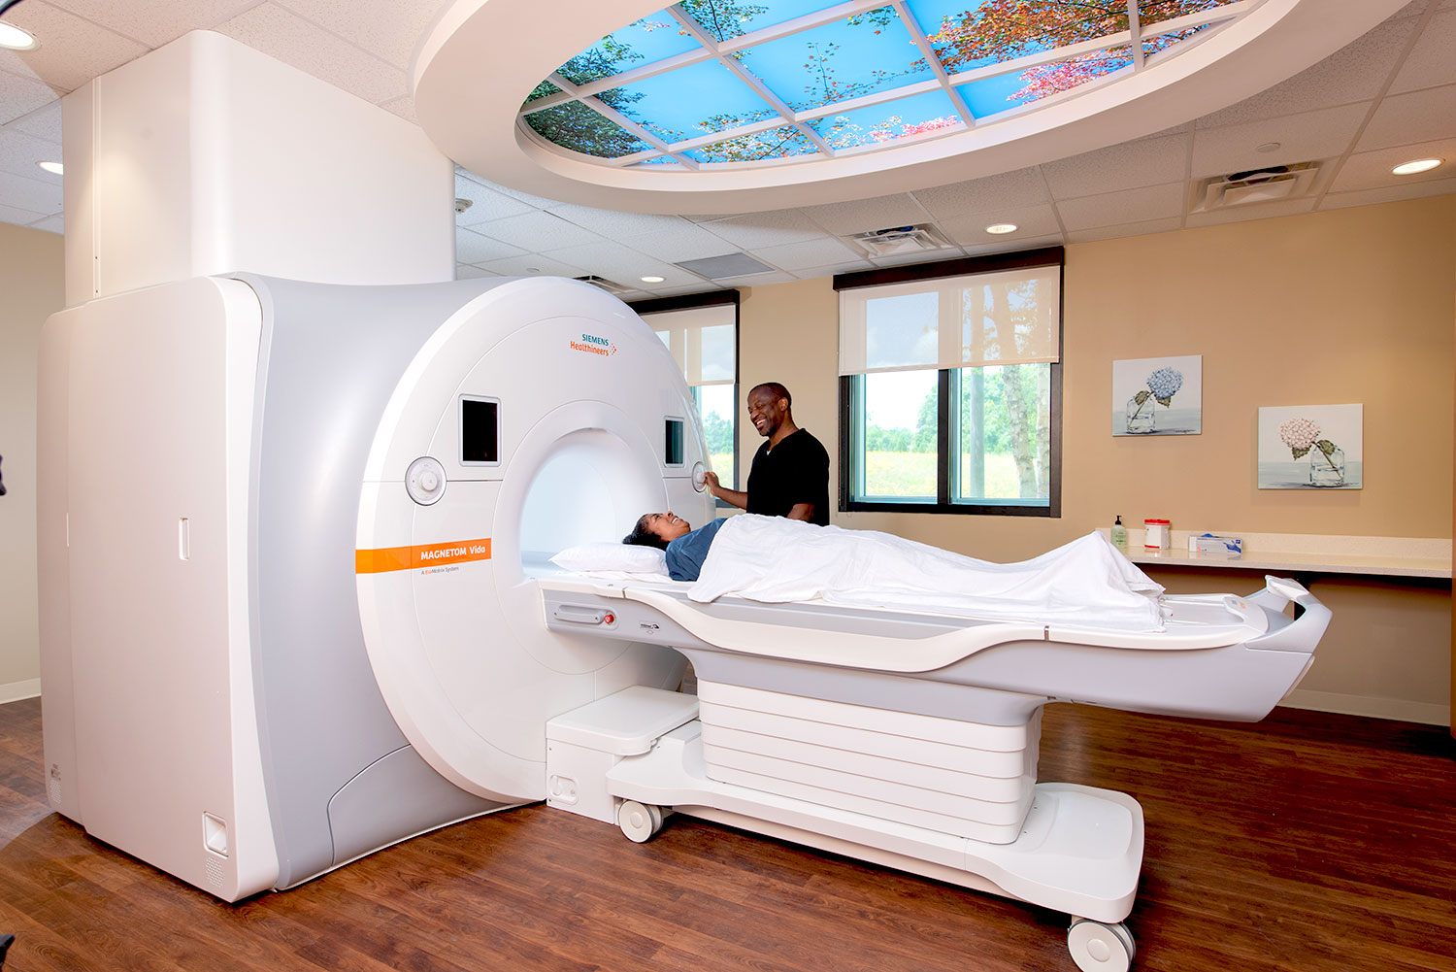

**Fig. 4.2 Magnetic Resonance Imaging (MRI)**

Ultrasound represents a non-invasive imaging modality that relies on high-frequency sound waves. This technology excels in real-time imaging, making it ideal for obstetrics, cardiology, and abdominal examinations. Obstetricians employ ultrasound to monitor fetal development, while cardiologists utilize it to assess heart function. Abdominal ultrasound is instrumental in identifying various medical conditions, offering a painless and safe diagnostic option.

Nuclear medicine introduces a novel dimension to diagnostic radiology, utilizing radiopharmaceuticals, radioactive materials introduced into the body, to create images of organ function. Positron Emission Tomography (PET) and Single Photon Emission Computed Tomography (SPECT) scans are prominent applications of nuclear medicine. These scans enable the detection and monitoring of diseases like cancer, offering insights into physiological processes at the molecular level.

Diagnostic radiology techniques are integral to clinical practice, serving as the eyes that peer into the human body's innermost recesses. Physicians rely on these techniques to make accurate diagnoses, plan surgeries, and monitor treatment progress. With ongoing technological advancements, the quality and precision of these imaging modalities continue to improve, further enhancing patient care.

**4.2 Interventional radiology (IR)**

Interventional Radiology (IR) marks a transformative juncture in the evolution of radiology. This subspecialty amalgamates imaging technology with minimally invasive procedures, ushering in an era of precision, reduced patient discomfort, and swifter recoveries. IR offers a compelling alternative to traditional surgical approaches, mitigating risks and hastening recovery times.

Angiography serves as one of the most recognized applications of interventional radiology. It entails the use of contrast agents and fluoroscopy to visualize blood vessels. Angiography is pivotal in diagnosing and treating conditions such as arterial blockages, aneurysms, and vascular malformations. Through catheter-based techniques, physicians can often resolve vascular issues without resorting to open surgery.

Embolization, another prominent IR procedure, involves introducing materials into blood vessels to obstruct or diminish blood flow. This approach has found utility in treating diverse conditions, including uterine fibroids and vascular malformations. Embolization may also serve as a critical tool in controlling bleeding in cases of trauma.



**Fig. 4.3 Uterine Fibroid Embolization**

Image-guided biopsies represent a linchpin in interventional radiology. Physicians harness imaging modalities such as CT or ultrasound to guide needle placement for biopsy procedures, ensuring precise tissue sampling. This precision is paramount in diagnosing suspected cancers and other diseases, facilitating timely intervention.

One of the compelling advantages of interventional radiology lies in its patient-centric approach. Procedures conducted in the realm of IR result in fewer complications, reduced pain, and briefer hospital stays compared to traditional surgical counterparts. Moreover, many IR interventions are now feasible on an outpatient basis, fostering convenience and diminishing the economic burden on the healthcare system.

The amalgamation of imaging and intervention in IR is not only transformative but also expands the horizons of what is feasible in medical practice. The interventional radiologist, equipped with real-time imaging guidance, wields the ability to deliver therapeutic agents directly to target areas or even perform intricate procedures within the vascular system. This level of precision fundamentally redefines patient care.

**4.3 Radiation therapy**

Radiation Therapy, also known as radiotherapy, constitutes a specialized domain within radiology that is focused on the treatment of cancer.[12] This approach employs high-energy radiation to target and eliminate cancer cells while minimizing collateral damage to adjacent healthy tissues.

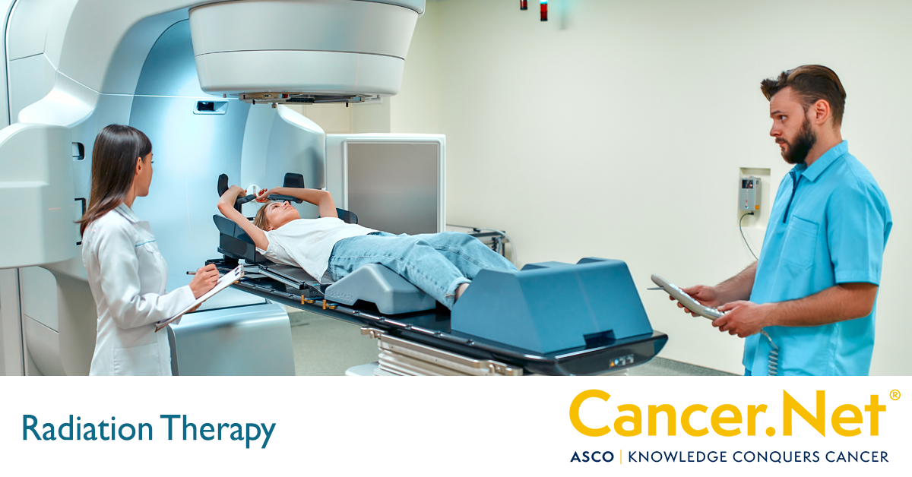

**Fig. 4.4 Radiation Therapy**

Central to the philosophy of radiation therapy is precision. The accurate planning and delivery of radiation are paramount, as they ensure the effective eradication of cancer cells while sparing normal tissues. This precision is facilitated through advanced technologies such as 3D conformal radiation therapy, intensity-modulated radiation therapy (IMRT), and stereotactic body radiation therapy (SBRT).

3D conformal radiation therapy represents a pivotal advancement in radiation therapy. It involves shaping radiation beams to align with the contours of the tumor, reducing radiation exposure to surrounding healthy tissues. This technique has significantly improved the therapeutic ratio, enhancing cancer control while minimizing side effects.

IMRT builds upon the principles of 3D conformal radiation therapy, allowing for the modulation of radiation intensity across different parts of the treatment field. This fine-tuning of radiation delivery affords even greater precision and control, enabling clinicians to target tumors with unparalleled accuracy. IMRT is particularly valuable when treating tumors near critical structures or those with irregular shapes.

SBRT, an innovative radiation therapy approach, administers exceptionally high doses of radiation in a limited number of sessions, often just a few. This technique is particularly effective for small, localized tumors, such as those found in the lung or liver. SBRT capitalizes on real-time imaging to track tumor motion and ensure pinpoint radiation delivery.

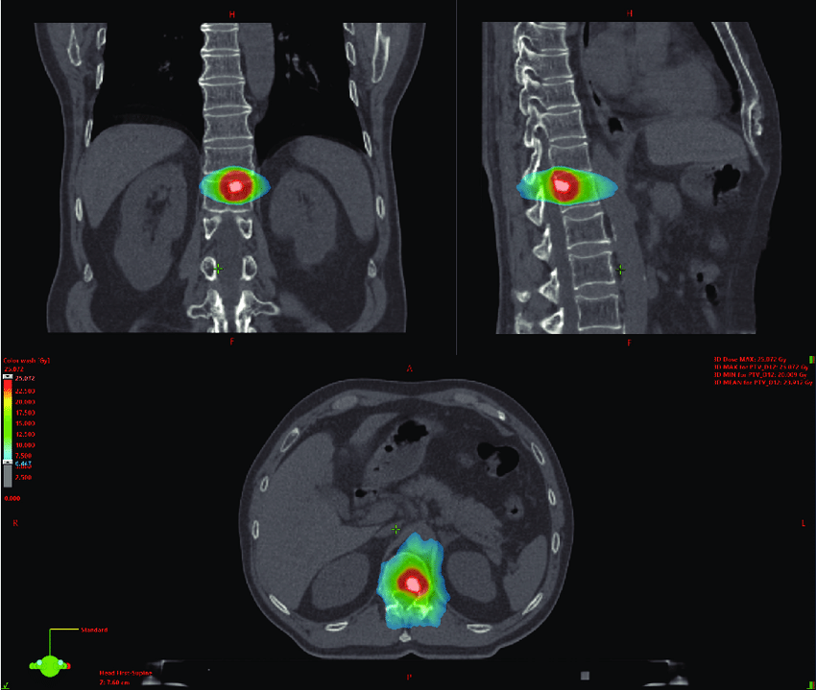

**Fig. 4.5 Stereotactic Body Radiation Therapy**

Radiation therapy is a versatile tool in the oncologist's arsenal. It can serve as a primary treatment modality to shrink tumors before surgery or as an adjuvant treatment post-surgery to eliminate residual cancer cells. Additionally, it provides palliative care, alleviating symptoms and enhancing the quality of life for patients with advanced cancer.

The emergence of image-guided radiation therapy (IGRT) has further heightened the precision of radiation treatment. IGRT leverages frequent imaging before and during treatment to ensure that radiation beams are accurately directed at the tumor. By accounting for variations in tumor position or shape, IGRT enhances the therapeutic ratio, assuring maximal tumor control with minimal toxicity.

Radiation therapy occupies a critical role in the multidisciplinary approach to cancer treatment. It frequently complements surgery, chemotherapy, and immunotherapy, contributing to comprehensive cancer care. The continually evolving landscape of radiation therapy promises even greater strides in cancer management, offering hope to patients and healthcare providers alike.

**4.4 Artificial Intelligence (AI)**

Artificial Intelligence (AI) is rapidly reshaping the landscape of radiology, ushering in an era of unprecedented advancements in image analysis, diagnostic accuracy, and workflow efficiency. AI algorithms have emerged as indispensable tools that augment the capabilities of radiologists, revolutionizing the field.

One of the primary applications of AI in radiology is the detection of abnormalities in medical images. AI algorithms, powered by deep learning and machine learning, have been meticulously trained on vast datasets of medical images. These algorithms can swiftly and accurately identify suspicious lesions, fractures, and other anomalies in X-rays, CT scans, MRIs, and other imaging modalities.[13] By flagging potentially problematic areas, AI assists radiologists in making more precise and timely diagnosis.

In addition to detection, AI plays a pivotal role in image segmentation. This involves the identification and delineation of specific structures or regions of interest within an image. AI-based segmentation is instrumental in treatment planning, enabling radiologists and oncologists to target tumors with pinpoint accuracy.

Automation of measurements and quantifications is yet another domain where AI shines. AI algorithms can rapidly and precisely quantify various parameters, such as the size, volume, and characteristics of lesions or anatomical structures. This data is invaluable for monitoring disease progression and treatment response.

The integration of AI into radiology represents a symbiotic relationship, where humans and machines collaborate to achieve optimal outcomes. Radiologists harness the analytical prowess of AI to assist in interpretation and diagnosis, while AI systems learn from radiologists' expertise to continually improve their performance.

The future of AI in radiology is promising. As AI algorithms continue to evolve and mature, their applications will expand. AI-driven predictive models may soon assist radiologists in anticipating disease progression, aiding in treatment planning and patient counseling.

However, the adoption of AI in radiology is not without challenges. Quality control and the need for rigorous validation of AI algorithms are paramount to ensure patient safety. Ethical considerations, including data privacy and informed consent, must be carefully addressed.

In conclusion, AI is a transformative force in radiology, enhancing diagnostic accuracy, workflow efficiency, and patient care. It exemplifies the synergy between human expertise and artificial intelligence, promising a future where radiologists are empowered with advanced tools to deliver superior healthcare.

**4.5 Emerging Trends and Challenges**

The dynamic field of radiology is continually evolving, propelled by emerging trends and technologies that promise to shape its future. Among these trends, the integration of 3D printing into radiology practice stands out. 3D printing technology enables the creation of patient-specific anatomical models based on medical imaging data. These models serve as invaluable tools for surgical planning and education, allowing surgeons to rehearse complex procedures and better understand patient anatomy.

Virtual reality (VR) and augmented reality (AR) are making substantial inroads in radiology. VR and AR technologies provide immersive visualization of medical images, offering a new dimension for understanding complex anatomical structures. These technologies enhance spatial awareness during surgery and facilitate preoperative planning.

Teleradiology, the remote interpretation of medical images, is becoming increasingly prevalent. Teleradiology services enable radiologists to provide expertise from a distance, making radiology accessible in underserved or remote areas. This trend has been particularly valuable in emergencies, where rapid image interpretation can be life-saving.

Despite these exciting trends, radiology faces its share of challenges. Patient safety remains paramount, and efforts to minimize radiation exposure in diagnostic imaging must continue. Radiation dose optimization, particularly in pediatric imaging, is an ongoing concern.

Data security and patient privacy have taken center stage in the age of digital healthcare. Radiology departments must rigorously safeguard patient information and comply with stringent data protection regulations. The secure transmission of medical images and reports is essential to maintaining patient trust.

Radiologists must adapt to the rapid pace of technological advancement. Staying current with the latest imaging techniques, AI tools, and software updates is imperative to provide the best possible care. Continuing education and professional development are essential components of a radiologist's career.

The integration of AI, while promising, also raises questions about its ethical use. Ensuring the transparency and fairness of AI algorithms and addressing biases in training data are crucial steps in AI deployment. Radiologists must maintain oversight and clinical judgment when relying on AI-generated insights.

Interdisciplinary collaboration is another emerging trend in radiology. Radiologists are increasingly working closely with clinicians, surgeons, and other specialists to provide comprehensive patient care. This collaborative approach ensures that imaging findings are integrated into the broader clinical context, leading to more informed treatment decisions.

In conclusion, radiology is a dynamic field that continues to evolve with emerging trends and technologies.[14] 3D printing, VR, AR, teleradiology, and interdisciplinary collaboration are reshaping the practice of radiology. However, radiologists must address challenges related to patient safety, data security, AI ethics, and ongoing professional development to navigate this rapidly changing landscape successfully. The future of radiology holds great promise, with the potential to revolutionize patient care and enhance diagnostic and therapeutic capabilities.

**Chapter 5**

**Conclusion and Recommendations**

***A]* Conclusion**

To sum up, the disciplines of computer vision and graphics have made remarkable progress in recent times. The fusion of these two fields has led to the emergence of new research and development opportunities, resulting in cutting-edge applications across various industries such as healthcare, entertainment, security, and autonomous vehicles.

Computer vision methodologies have amplified the ability of graphics systems to engage with their surroundings in real-time, thereby facilitating more immersive and lifelike experiences. Conversely, progress in graphics has played a crucial role in enhancing the precision and efficiency of computer vision algorithms by supplying superior data quality and robust visualization instruments.

Nevertheless, in spite of these advancements, there are still obstacles that need to be tackled. These encompass issues associated with the computational power needed for intricate calculations, the demand for substantial volumes of high-grade data for model training, and the assurance of data privacy and security.

Anticipated future endeavors in this sphere are likely to concentrate on surmounting these obstacles and discovering novel methods to amalgamate computer vision and graphics. This could potentially result in the creation of more sophisticated systems capable of comprehending and interacting with their environment in ways that were previously thought to be beyond reach.

In essence, the synergy between computer vision and graphics is a beacon of hope for the future, laying the groundwork for revolutionary innovations that could transform various facets of our lives.

***B]* Recommendation**

Based on the analysis and findings discussed in the previous chapters, we propose the following recommendations:

1. Interdisciplinary Research: The field of computer vision is versatile and finds its use in numerous sectors such as healthcare, self-driving vehicles, and more. It is suggested that future studies could concentrate on these cross-disciplinary uses of computer vision.
2. Ethics and Privacy: With the widespread adoption of computer vision technologies, ethical and privacy concerns are becoming more and more significant. It is crucial that future research doesn’t just concentrate on enhancing the technical facets of computer vision, but also takes into account these ethical considerations.
3. Data Augmentation Techniques: The efficacy of computer vision models is profoundly dependent on the volume and quality of data at hand. Hence, the creation of novel data augmentation methods to enhance the training dataset could be a promising avenue for future investigation.
4. Real-time Processing: Processing visual data in real-time is a notable hurdle in the realm of computer vision and graphics. Future endeavors should strive to devise methods and algorithms capable of real-time analysis and processing of visual data.
5. Hardware Optimization: As models become increasingly complex, the need for hardware capable of supporting these models grows. Future research could explore ways to optimize hardware to handle the demands of intricate computer vision tasks.
6. Deep Learning Models: The emergence of deep learning has led to substantial advancements in the field of computer vision. Nonetheless, there’s still potential for enhancement. Future studies should concentrate on creating more precise and efficient models, especially for intricate tasks like object detection and segmentation.
7. Integration of Computer Vision and Graphics: The trend of merging computer vision and graphics to craft more immersive experiences, such as those found in AR/VR applications, is on the rise. Future endeavors should delve deeper into this fusion.

These suggestions are intended to steer the direction of future investigations in the field of computer vision and graphics.By focusing on these areas, we can anticipate continued advancements and innovations in this exciting field……

**LIST OF REFERENCES**

**Webliography**

[1]GeeksforGeeks, “Introduction to computer graphics,” *GeeksforGeeks*, May 2023, [Online]. Available:https://www.geeksforgeeks.org/introduction-to-computer-graphics/

[2]“What is Computer Vision? | Microsoft Azure,” *Microsoft Azure*. https://azure.microsoft.com/en-in/resources/cloud-computing-dictionary/what-is-computer-vision/#:~:text=Computer%20vision%20is%20a%20field,tasks%20that%20replicate%20human%20capabilities.

[3]W. E. Carlson, “The history of early computing technology,” *Pressbooks*, Jun. 20, 2017. https://ohiostate.pressbooks.pub/graphicshistory/chapter/the-history-of-early-computing-technology/

[4]W. E. Carlson, “1.1 Early analog computational devices,” *Pressbooks*, Jun. 20, 2017. https://ohiostate.pressbooks.pub/graphicshistory/chapter/1-1-early-analog-computational-devices/

[5]W. E. Carlson, “2.1 Whirlwind and SAGE,” *Pressbooks*, Jun. 20, 2017. https://ohiostate.pressbooks.pub/graphicshistory/chapter/2-1-whirlwind-and-sage/

[6]W. E. Carlson, “7.1 CG organizations and conferences,” *Pressbooks*, Jun. 20, 2017. https://ohiostate.pressbooks.pub/graphicshistory/chapter/7-1-cg-organizations-and-conferences/

[7]“Computer Vision Applications - JavaTPoint,” *www.javatpoint.com*. https://www.javatpoint.com/computer-vision-applications

[8]Simplilearn, “What is computer Vision: applications, benefits and how to learn it,” *Simplilearn.com*, Aug. 2023, [Online]. Available:https://www.simplilearn.com/computer-vision-article

[9]G. Boesch, “The 100 most popular Computer Vision applications in 2023,” *viso.ai*, Mar. 2023, [Online]. Available:https://viso.ai/applications/computer-vision-applications/

[10]A. Esteva *et al.*, “Deep learning-enabled medical computer vision,” *Npj Digital Medicine*, vol. 4, no. 1, Jan. 2021, doi: 10.1038/s41746-020-00376-2.

[11]“Computer Vision in Radiology: How ML will disrupt the future of clinical radiology–PostIndustria.”

https://postindustria.com/computer-vision-in-radiology-how-ml-will-disrupt-the-future-of-clinical-radiology-healthcare/

[12]“Deep learning for computer vision,” *Center for Artificial Intelligence in Medicine & Imaging*. https://aimi.stanford.edu/research/focal-areas/deep-learning-computer-vision

[13]P. M. Cheng *et al.*, “Deep learning: an update for radiologists,” *Radiographics*, vol. 41, no. 5, pp. 1427–1445, Sep. 2021, doi: 10.1148/rg.2021200210.

[14]S. Javaid, “Computer Vision in Radiology in 2023: Benefits & Challenges,” *AIMultiple*, Jan. 2023, [Online]. Available:https://research.aimultiple.com/computer-vision-radiology/

**Bibliography** *(For Further Research)*

[1] D. Hearn and B. M. Pauline, *Computer Graphics - C version 2nd Ed*. 2016. [Online]. Available: http://repository.unimal.ac.id/811/

[2] J. D. Foley, A. Van Dam, S. Feiner, and J. F. Hughes, *Computer graphics (2nd ed. in C): principles and practice*. 1995. [Online]. Available:https://doi.acm.org/10.1145/208249

[3] C. Steger, M. Ulrich, and C. Wiedemann, *Machine Vision Algorithms and Applications*. John Wiley & Sons, 2018.

[4] S. J. D. Prince, *Computer Vision: Models, Learning, and Inference*. Cambridge University Press, 2012.